
How to Sew Pajama Pants Without a Pattern-Easy Sew
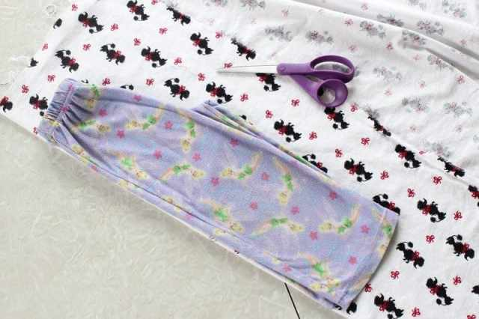

To sew pajama pants without the hassle of a pattern, just grab a pair that you already have.
Fold them in half, laying the fold of the pants on the fold of the fabric.
Cut out the pants, making sure to leave at least 1/2″ for seam allowances.
Add inches in areas that you are trying to increase the size in. If the pants are already the correct size, just add the 1/2″ for the seams.
You will need around 3″ on the top for the elastic casing.
You will need to cut two sections like this. One for each leg.

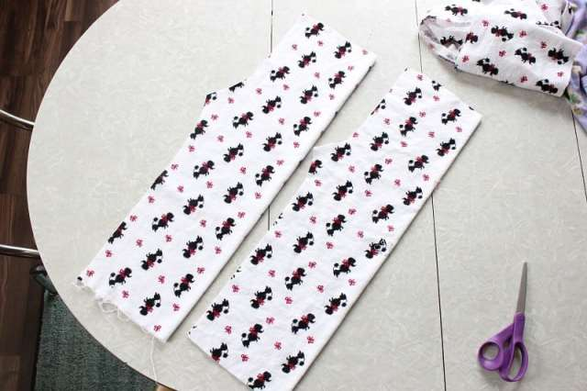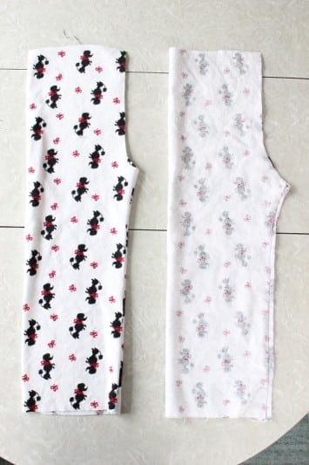

Fold them inside out and sew along outer leg edge (from the bottom, to where the crotch begins to curve). Trim close to seams.
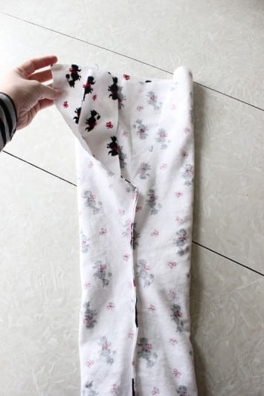

Turn one leg right side out and stuff it inside the other leg. Right sides of fabric will be facing each other. Make sure that the long seam that you just sewed on each leg matches the other. Pin in the center to keep it in place.

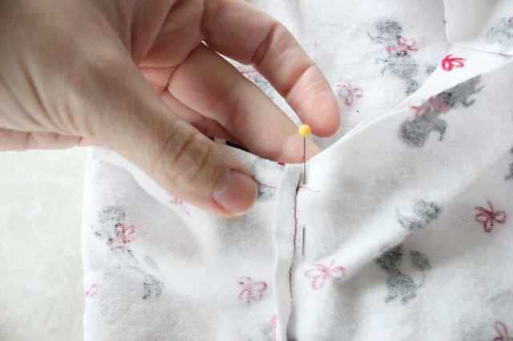
Sew the crotch seam. Begin at the waist, sew along and end at the top again.

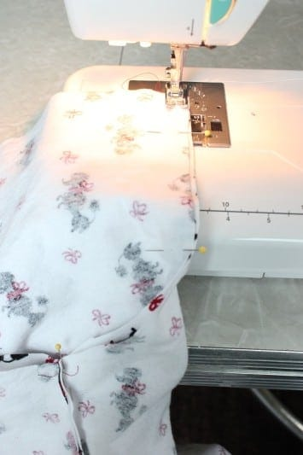

Sew once more close to the seam line to reinforce since this area will get a lot of wear.

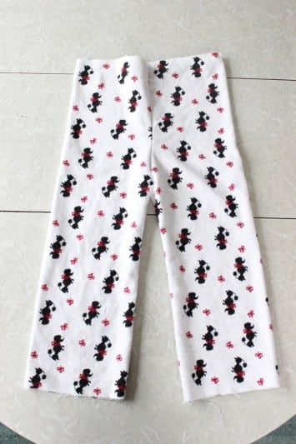

Turn pants right side out. Almost done!

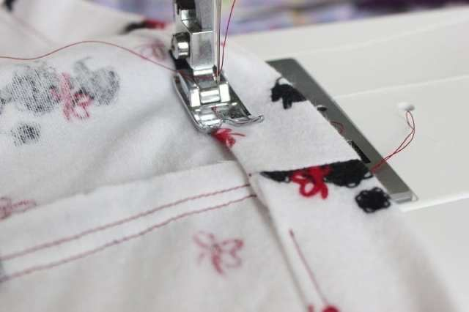

Use 3/4″ elastic. Fold down the waist 1/4″ inch and press it. Then folded it another 1 1/4 inch and sewed the casing all the way around with a 1/4″ seam, also leaving a 2″ gap to insert the elastic into later.

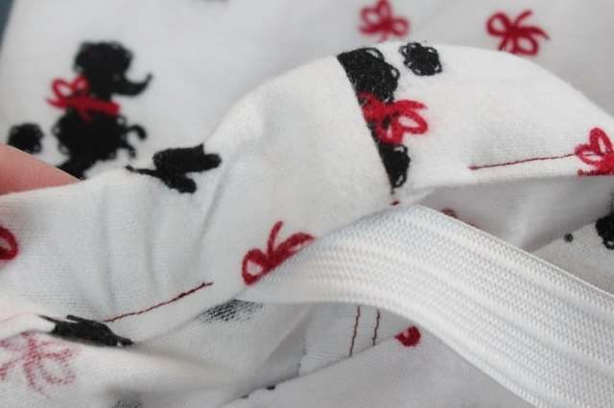
Insert your elastic using a safety pin to help guide it through the waist band. The elastic should be the same size as your waist + 1″.

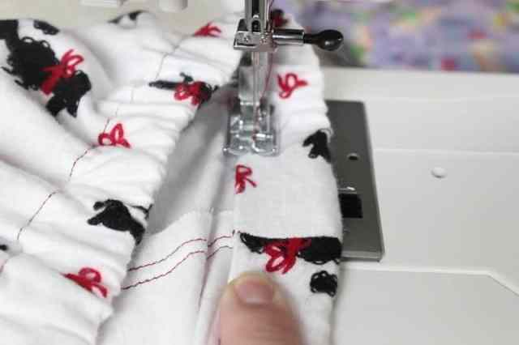

Sew ends together. Stretch the waist, pulling the elastic back into the opening. Sew the gap closed.
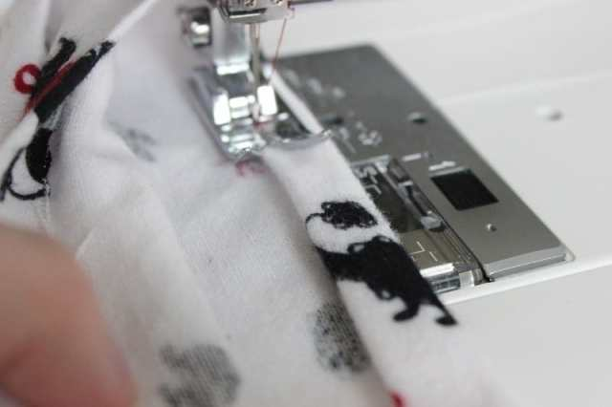
Fold up hem and press, then fold up one more time and press. This one is about 1/2″. Sew around on both legs. Flannel is so easy to work with. You may not need pins since it pretty much just sticks together.
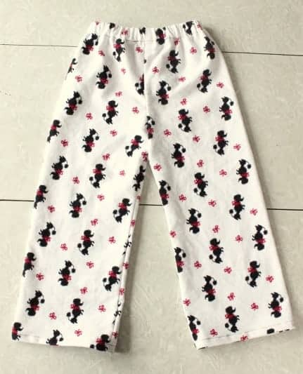
You are finished your pajama pants!
*If you prefer, a commercial pattern can be used.

